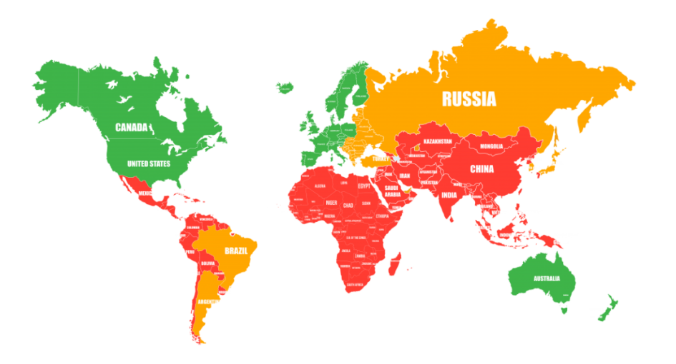 **List of countries from Tier 1,2,3**

|  |  |  |
| --- | --- | --- |
|  |  |  |
| Australia Austria  Belgium United Kingdom  Germany  Denmark Spain  Italy Canada  Netherlands  Norway  Singapore  UNITED STATES  Finland France  Switzerland  Sweden | |  |  | | --- | --- | | Andorra  Argentina  Belarus  Bulgaria  Bolivia  Brazil  Brunei  Vanuatu  Hungary  Hong Kong  Greece  Dominican Republic  Egypt  Israel  Indonesia  Iceland  Kazakhstan  Qatar  Cyprus  China  Colombia  Costa Rica  Latvia  Lithuania  Malaysia  Malta  Morocco  Mexico  Nepal  United Arab Emirates  Oman  Panama  Paraguay  Peru  Poland  Portugal  Puerto Rico  Russia  Romania  Saudi  Arabia |  | | Azerbaijan  Albania  Algeria  Angola  Armenia  Bangladesh  Barbados  Bahrain  Belize  Benin  Botswana  Burkina Faso  Burundi  Viet Nam  Gabon  Haiti  Guatemala  Guinea  Honduras  Georgia  Zambia  India  Jordan  Iraq  Cambodia  Cameroon  Kenya  Congo  Kuwait  Laos  Lesotho  Lebanon  Madagascar  Macedonia  Had  Moldova  Mongolia  Namibia  Niger  Nigeria  Nicaragua |

|  |  |  |
| --- | --- | --- |
|  |  |  |
|  | Serbia  Slovakia  Slovenia  Thailand  Turkey  Ukraine  Uruguay  Philippines  Croatia  Montenegro  Czechia  Chile  Ecuador  Estonia  South Korea  YUAP  Japan | Pakistan  El Salvador  Swaziland  Senegal  Tajikistan  Tanzania  Tunisia  Turkmenistan  Uganda  Uzbekistan  Chad  Sri Lanka  Ethiopia  Jamaica |